**Summary for "Gesture Controlled Virtual Mouse"**

**Project Overview**

This project involves controlling a computer mouse using hand gestures detected through a webcam, offering a touchless interface for interacting with devices.

**Key Components**

1. **Workflow:**
   * **Video Capture:** Real-time video input through OpenCV.
   * **Hand Detection:** Using MediaPipe to track hand landmarks.
   * **Gesture Recognition:** Identifying gestures based on hand positions.
   * **Mouse Control:** Executing actions like clicks, scrolling, and screenshots.

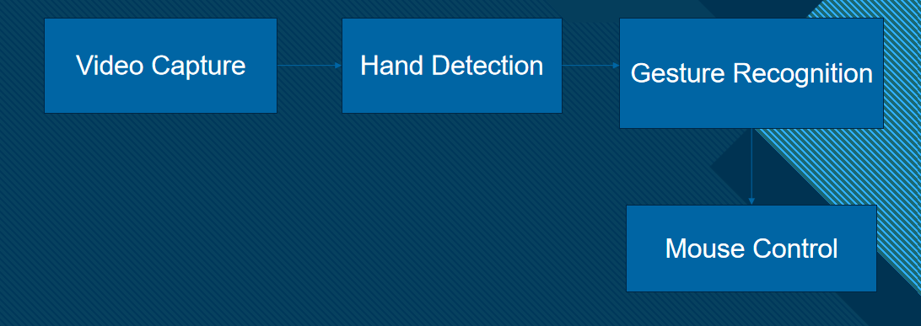

1. **Tools and Libraries Used:**
   * **OpenCV:** Video frame capture and display.
   * **MediaPipe:** Hand landmark tracking with 21 key points.
   * **PyAutoGUI:** Automating mouse actions.
   * **Pynput:** Low-level mouse control.
   * **Random:** Generating random numbers for auxiliary features.

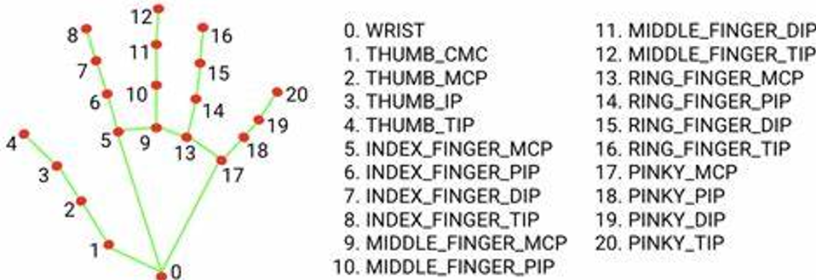

1. **Gesture Detection:**
   * **Left Click:** Thumb (Landmark 4) and Index (Landmark 8) close together.

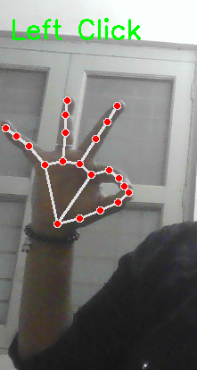

* + **Right Click:** Thumb (Landmark 4) and Middle Finger (Landmark 12) close together.

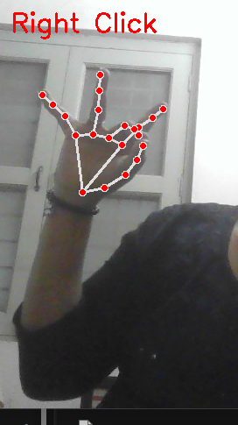

* + **Scroll Up/Down:** Middle Finger (Landmark 12) moves up or down.

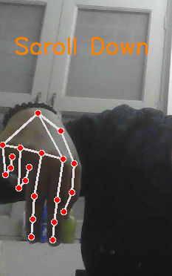

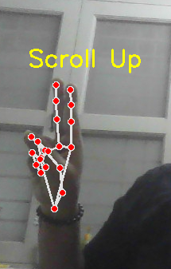

* + **Screenshot:** Thumb (Landmark 4) and Little Finger (Landmark 20) close together.

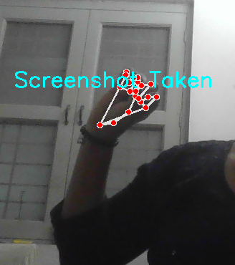

1. **Challenges Encountered:**
   * Variable lighting affecting detection accuracy.
   * Limited gesture library.
   * High CPU usage for real-time processing.
2. **Improvement Opportunities:**
   * Adding support for multiple hands.
   * Customizable gestures for more actions.
   * Integration with AR/VR systems.

**Applications**

* Touchless control for presentations.
* Gaming and virtual reality interfaces.
* Smart home control systems.

**ChatBot:**

A chatbot is a vital tool for enhancing user experience by providing **instant support** and **24/7 availability**. It simplifies communication by answering frequently asked questions, guiding users, and automating repetitive tasks. Chatbots save time, reduce human effort, and improve efficiency in customer service and business processes. They are highly scalable and can handle multiple queries simultaneously, ensuring quick and accurate responses.

